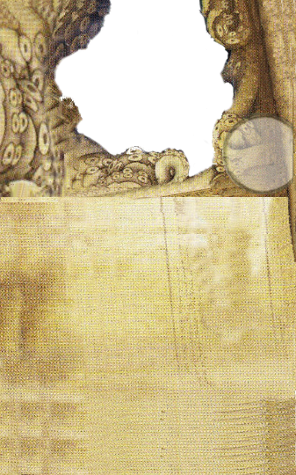







*Wrestler*

During your turn, you may discard this card to resolve a free Push action. If successful, you may choose for your target to suffer 1 Damage.

*Scientific Approach*

You may discard this card to either gain 2 extra Puzzle steps or interact with a Puzzle in range.

*Quick Study*

During your turn, you may discard this card to take a free action for one Spell\Item card you possess. The action may not be an Attack action.

*Mystic Foresight*

Once per turn, you may read the hidden side of a Spell card in your possession and then you may discard this card to replace the Spell card.



*Flying Kick*

Before an Unarmed Attack, you may discard this card and, if you deal Damage, deal 1 additional Damage and move 1 space.



*Self-Control*

If you go insane, after you read your Insanity card, you may discard this card to discard the Insanity and draw another.

*Artful Dodger*

During your turn, you may discard this card to perform a free Move action ignoring Evade tests.

*Occult Insight*

You may discard this card to gain 2 extra puzzle steps.

*Calming Prayer*

If you use your investigator ability, you may discard this card to flip 1 Horror facedown.

*Reveal Secrets*

Discard this card

and 1 

for an investigator in range to gain 1 .

*Eager to Help*

**Action:** Another investigator in range may perform 1 action and, then, discard this card.

*Binding Command*

Discard this card to suffer no Horror from a game effect or test.

During your turn, you may discard this card to place a Restraint token in a space in range.

*Quick Thinking*

When resolving a test, you may discard this card to convert as many dice as you choose to a  result.

*Occult Research*

During your turn, you may discard this card and spend 1 

to cast a Spell without spending an action.























*Past Lives*

When resolving a test, you may discard this card to re-roll all your dice.

*Shoot and Roll*

After resolving a Firearm Attack, you may discard this card to move 1 space.